**Introduction:** You are to produce the risk assessment for a project that will be undertaken in the HV laboratory. To allow you to do this you are provided with details of the equipment to be tested and the generator that will be used to apply a high voltage to that equipment. You will be able to see this equipment and the generator before you complete the risk assessment process.

**Purpose Of The Project:** The insulating gas sulphur hexafluoride (SF6) is widely used in the electricity supply industry. It has a high dielectric strength and is used at a gas pressure of 4-5 times atmospheric within gas insulated substations. The project is testing out a new form of insulating gas, Novec 4710, to see if when mixed with carbon dioxide whether it can replace SF6. A piece of gas insulated busbar will be assembled in the high voltage laboratory and tested with the alternative gas mix. Testing will be carried out using transient voltages representative of those taking place when lightning hits an overhead line / those taking place during switching operations.

**Equipment To Be Tested:** The equipment to be tested is a piece of gas insulated busbar – this has an inner conductor that is placed within the outer metallic casing. The outer casing is earthed while the inner busbar operates at high voltage. The enclosure is pressurised at 4-5 times atmospheric pressure and is filled with gas contained at even higher pressures with commercial cylinders. A large bushing is provided to allow an external electrical connection to be made with the internal metal busbar. Each section of the gas insulated busbar and the bushing has a mass of between 100kg and 1000kg.

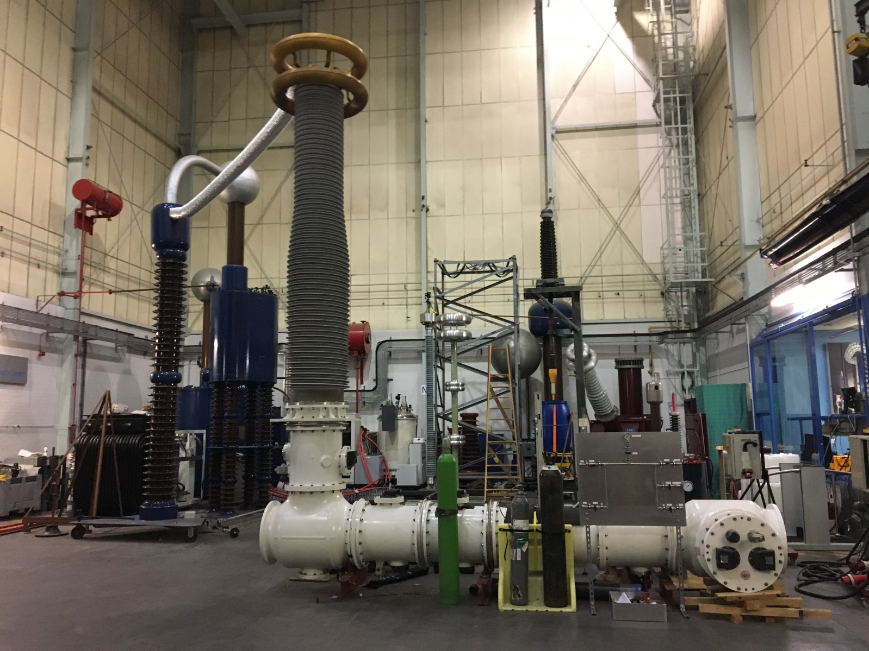

**Test System:** The impulse generator will be used to test the gas insulated busbar. The impulse generator circuit is below. A number of capacitors are charged in parallel using a high voltage DC supply. When the generator is required to fire, a small voltage impulse is imposed on the first set of sphere gaps causing them to flashover. This causes the remaining gaps to flashover and the capacitors to be connected in series. As a result, a voltage roughly equal to nVs where n is the number of parallel capacitors and Vs is the voltage level used to charge the capacitors is produced at the test object. The voltage is measured with a voltage divider and is connected to the computerised monitoring system within the control room. The generator has in-built safety systems that include a link with the laboratory interlocks. Should the door to the laboratory be opened when the generator is energised, charging will stop and automatic earths will be deployed to make the generator safe.

**Procedures:** Your risk assessment should cover the following phases of the project:

* **Construction of the test object including filling with gas:** The test object will be delivered on a lorry and lifted off using the laboratory crane before it is assembled. Once assembled any gas will be evacuated using a vacuum pump before it is filled with a Novec /CO2 mixture.
* **Preparation of the impulse generator test circuit:** To prepare the impulse generator test circuit, an individual must climb the internal ladder to set the appropriate resistor values. The voltage divider is then moved into position and wires connected at a high level from the test object bushing to the divider and then the generator.
* **Testing of the gas insulated busbar:** In this phase approximately 40 applications of a voltage with a peak value of 1050kV will be made to the test system. The testing will be carried out from the HV laboratory control room with the interlock key only being issued to a competent person.

**Impulse Generator Circuit Diagram**

